# Software Engineering and Project Management Lab Experiment No: - 10 Aim: To Study and Implement Dockerfile instructions

**Aim:** To learn Dockerfile instructions, build an image for a sample web application using DOCKERFILE.

## Theory:

A container is a standard unit of software that packages up code and all its dependencies so the application runs quickly and reliably across different computing environments. Docker provides a platform for developing, shipping, and running containers easily.

### Key Features of Containers:

* Isolation: Each container runs in its own isolated environment.
* Portability: Containers can run consistently across any system.
* Lightweight: Share OS kernel, making them more efficient than virtual machines.
* Scalable: Easily deploy and replicate containers across clusters.
* Fast Deployment: Start in seconds, ideal for CI/CD and agile development.
* Reproducible: Same environment from development to production.

### Docker as a Container Platform

Docker enables you to create and manage containers using simple commands. It allows you to containerize applications and services with ease and deploy them in any environment.

### Key Docker Container Components:

**Component Purpose**

Dockerfile Blueprint to build a Docker image

Docker Image Snapshot of the app and its dependencies Docker Container Runnable instance of a Docker image Docker CLI Command-line tool to interact with Docker

Docker Daemon Background process managing Docker containers Docker Hub Online repository to store and share images

### Demonstration of Running a Container using Docker (Theoretical Steps)

1. Install Docker
   1. Download and install Docker Desktop from https://[www.docker.com.](http://www.docker.com/)
   2. Start Docker on your local machine.
   3. Verify installation by running:

*docker --version*

1. Pull a Base Image
   1. Use Docker Hub to pull a popular image (e.g., Ubuntu, Nginx, Python):

*docker pull ubuntu*

TSEC Batch:-T12 Name & Roll No:- Sarthak Hinge - 35

# Software Engineering and Project Management Lab Experiment No: - 10 Aim: To Study and Implement Dockerfile instructions

1. Run a Container from an Image
   1. Use the docker run command:

*docker run -it ubuntu*

* 1. This opens an interactive terminal session in the container.
  2. Run Linux commands inside the container (e.g., ls, pwd, apt update).

1. Exit the Container
   1. Type exit to close the session and stop the container.
2. List Running and Stopped Containers
   1. View active containers:

*docker ps*

* 1. View all containers (including stopped ones):

*docker ps -a*

1. Remove Containers
   1. Stop the container (if still running):

*docker stop <container_id>*

* 1. Remove the container:

*docker rm <container_id>*

1. Run a Web Server Container (Optional)
   1. Run a web server (e.g., Nginx):

*docker run -d -p 8080:80 nginx*

* 1. Open http://localhost:8080 in browser to see the Nginx welcome page.

### Use Case Example:

* Running a Linux environment on any OS for testing
* Hosting a web server like Apache or Nginx inside a container
* Developing and testing Python, Node.js, or Java apps
* Containerizing databases like MySQL or MongoDB for quick use
* Experimenting with new tools and languages without affecting host OS
* Education and training in DevOps or system admin practices
* Deploying a standalone app for development or demonstration

**Implementation:**

TSEC Batch:-T12 Name & Roll No:- Sarthak Hinge - 35

# Software Engineering and Project Management Lab Experiment No: - 10 Aim: To Study and Implement Dockerfile instructions

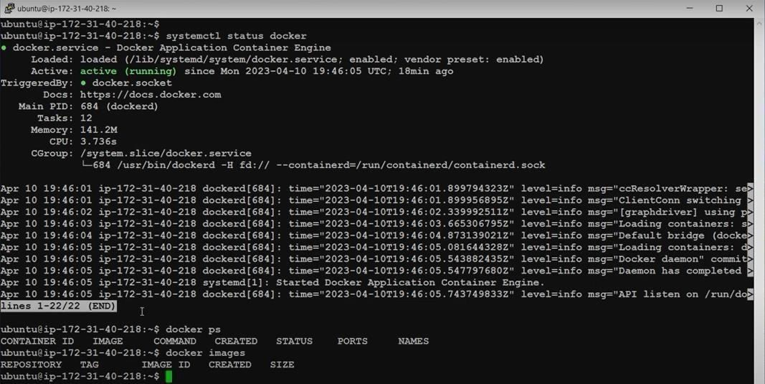

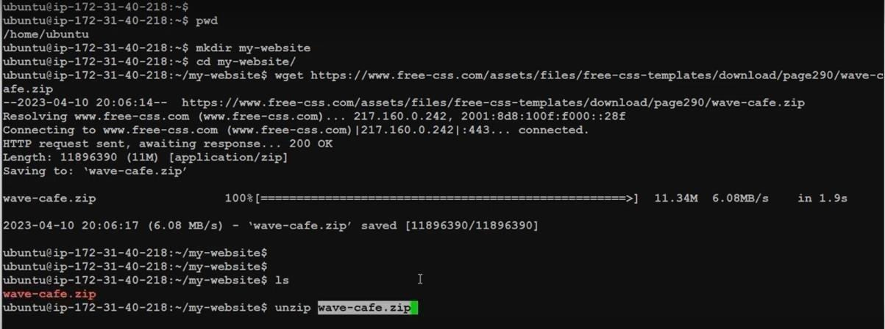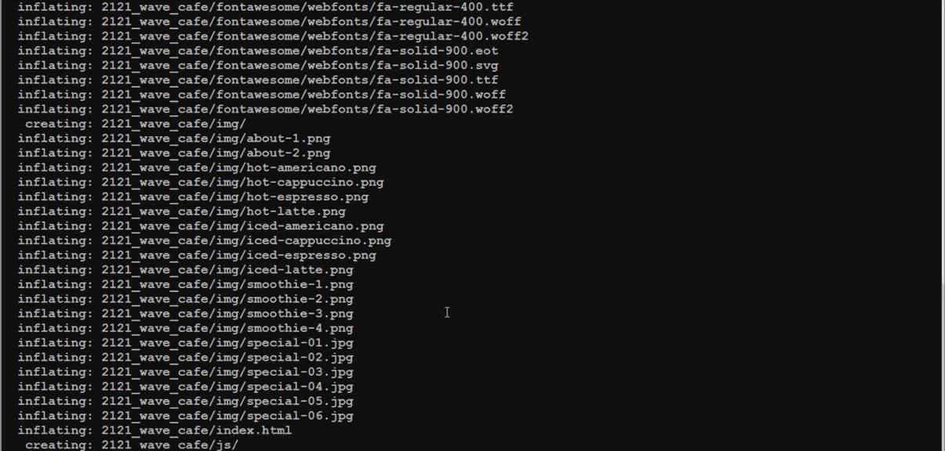

TSEC Batch:-T12 Name & Roll No:- Sarthak Hinge - 35

# Software Engineering and Project Management Lab Experiment No: - 10 Aim: To Study and Implement Dockerfile instructions

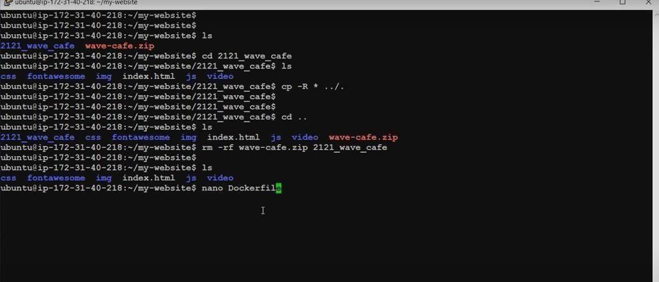

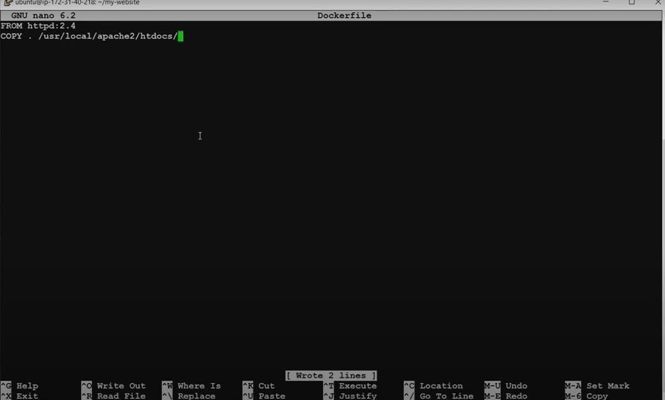

TSEC Batch:-T12 Name & Roll No:- Sarthak Hinge - 35

# Software Engineering and Project Management Lab Experiment No: - 10 Aim: To Study and Implement Dockerfile instructions

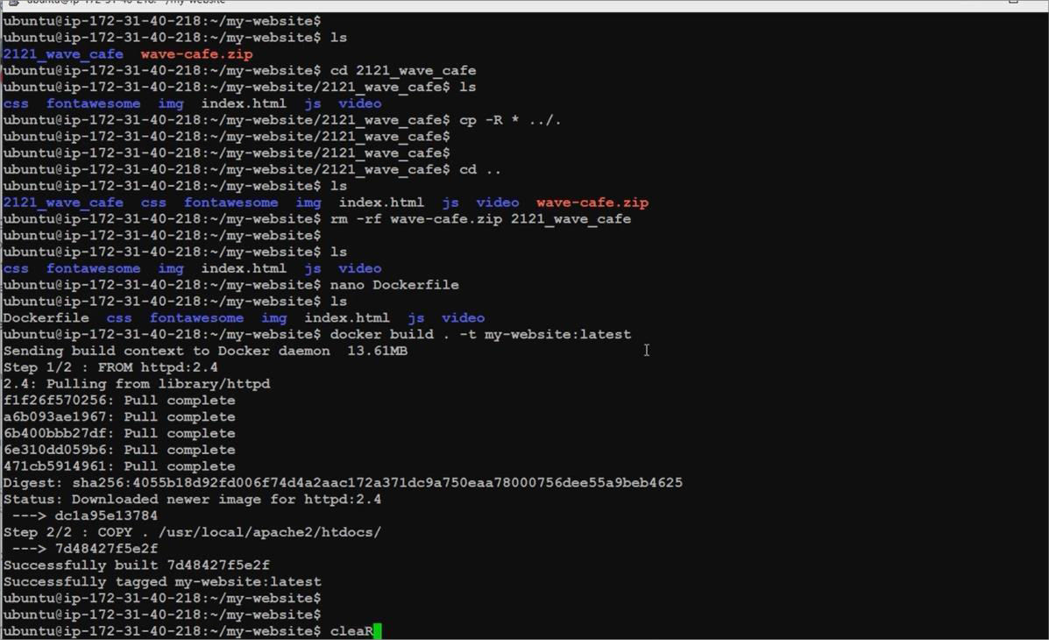

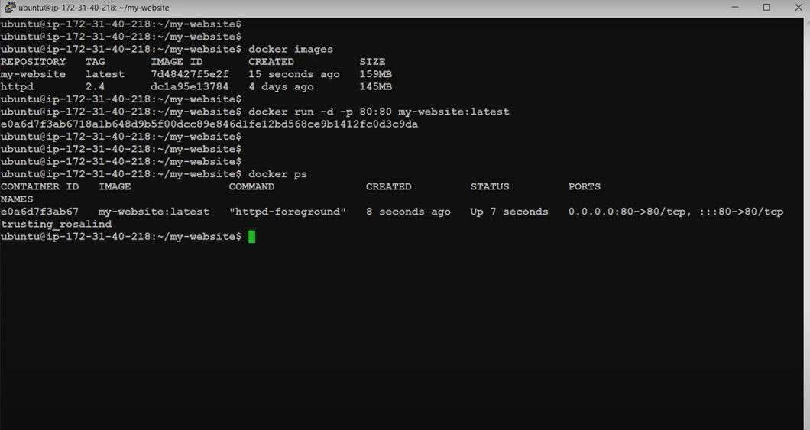

TSEC Batch:-T12 Name & Roll No:- Sarthak Hinge - 35

# Software Engineering and Project Management Lab Experiment No: - 10 Aim: To Study and Implement Dockerfile instructions



**Conclusion:** We have successfully understood Dockerfile instructions, build an image for a sample web application using DOCKERFILE.

**LO Mapping:** *LO is mapped*

TSEC Batch:-T12 Name & Roll No:- Sarthak Hinge - 35